1. In the last lecture, we created a new component called **server.component.ts**. That component is ready to use but in order to use it, we need to configure that component in **app.module.ts** to inform angular that we can use this component in this module.
2. **What is this app.module.ts?**
   1. Angular uses these components to build our web pages and uses modules to basically bundle different pieces for example components of your app into packages.  
      Module = Package = For Components (etc)  
      Later on, we have a separate section about modules.
   2. For majority of the projects, we use only app module which is fine but for very big project, you create more than one module by splitting up your app.
   3. **App Module**: It is bundle of functionalities that gives info to angular about the features/functionalities that this module has.  
      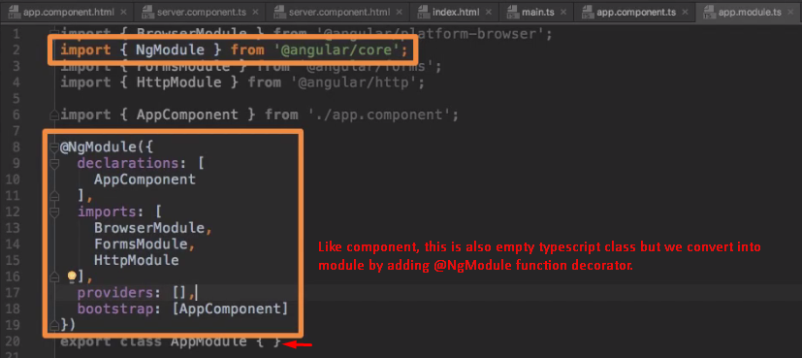
   4. 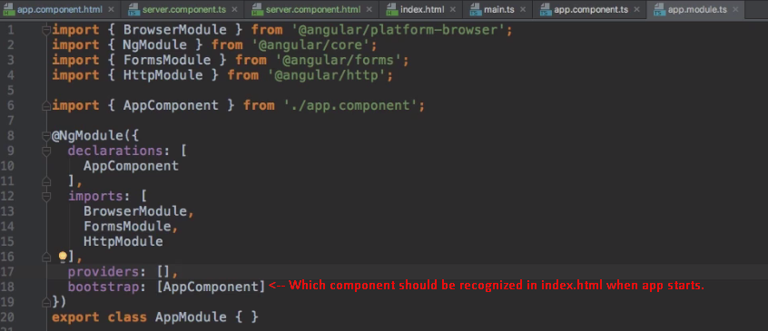
3. 